SOFTWARE TESTING REPORT

# EZPoll

Team Members:

Aayush Maurya

1901002

Abhishek Raut

1901010

Gaurav Gupta

1901068

**─**

# 

# Overview

This project is a simple website for creating and giving poll and user opinion. This allows user to create poll and take users vote to this. This also allows to create a voting portal in which user can restrict the list of voters who are eligible to give vote. This will allow user to create a portal insimple as well as complex way. The app will help to take vote and opinion in a simple and affordable method.

# TESTING

## Script Testing

**FORMS**

We have performed testing to check if all the forms are working correctly and checked for all possible error.

The below is the test result for all the forms including client signup, client login and voter login.

For this we have created a dummy client and voter and checked if the form are responding in the same way as it is designed to be.

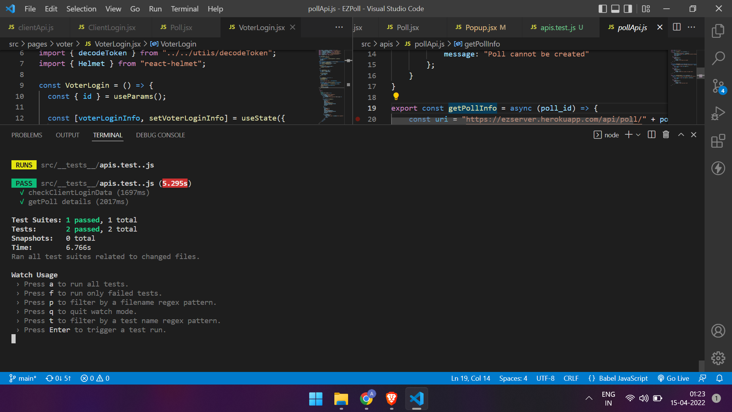

**UTILS**

We have created two helper functions under utils folder. One for setting the authorization token in the header of every api request once a client is logged in. Since the server will not accept any client api request if the authorization token is not in the request header. Second is for decoding the token sent by server. This token is sent by server if client is logged in, which contains all the required details of the client in form of coded token. This token must be decoded in order to extract all the details of the client.



## Manual Testing

The below tests are performed manually because the apis which we are testing for require client auth token in their header which we have putted manually while checking it.

**POLLS**

In this testing we have created a dummy poll and checked if it is being created successfully.

Also used the created poll to check if the vote is being successfully submitted or not. Also it is checked if the it is showing “already voted” if a voted is given from same IP address again.

Creating poll:

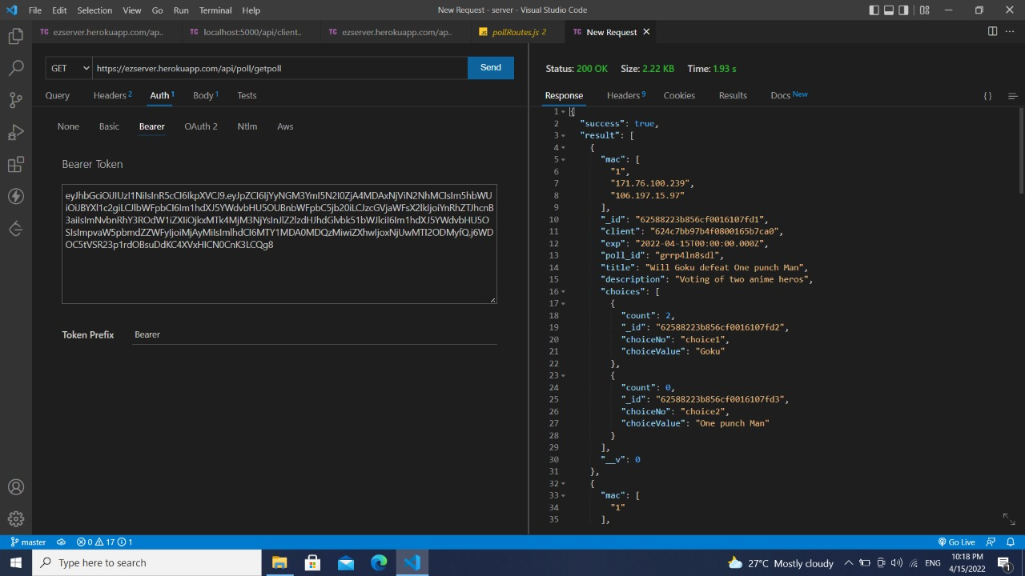

Giving vote to poll:

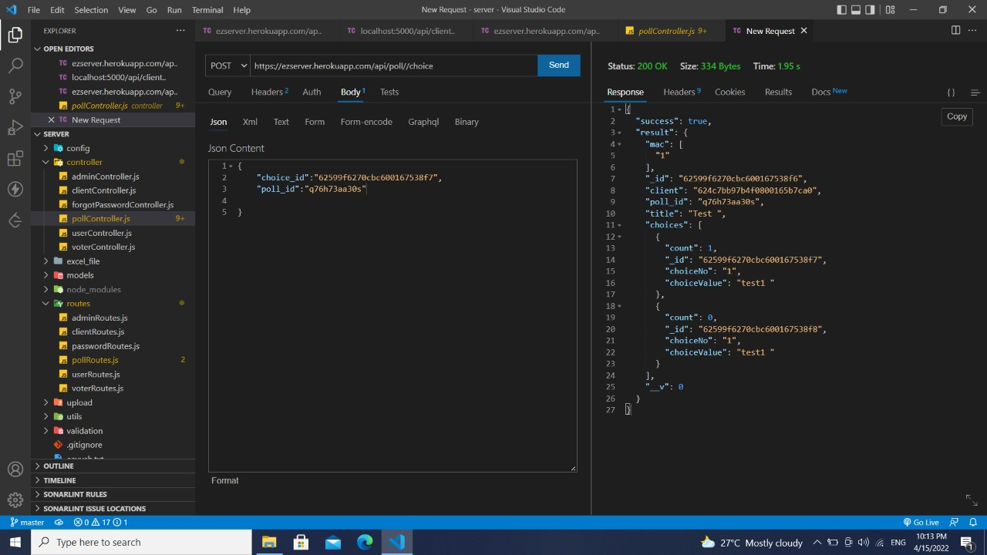

**CREATING VOTE**

In this testing we have checked if vote is creating successfully or not. We are giving dummy data to create vote.

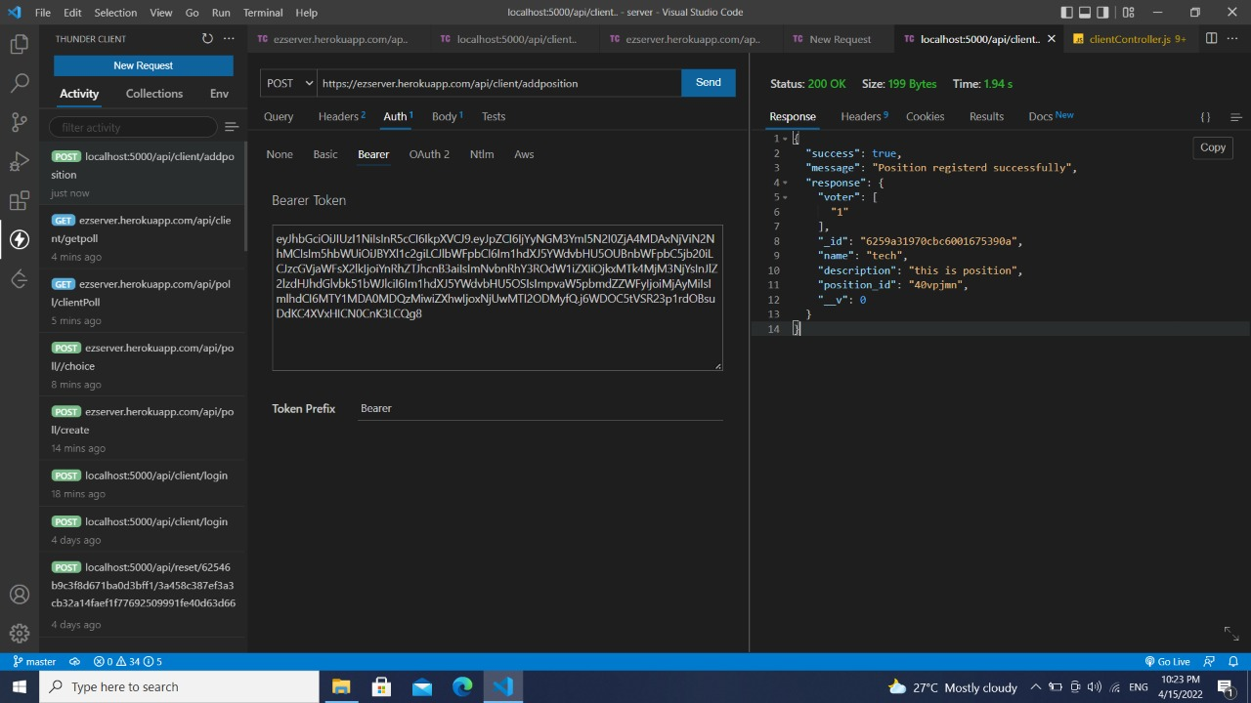

**ADDING CANDIDATE**

Using the the above created vote we have added dummy candidates to the vote and checked if it is working or not.

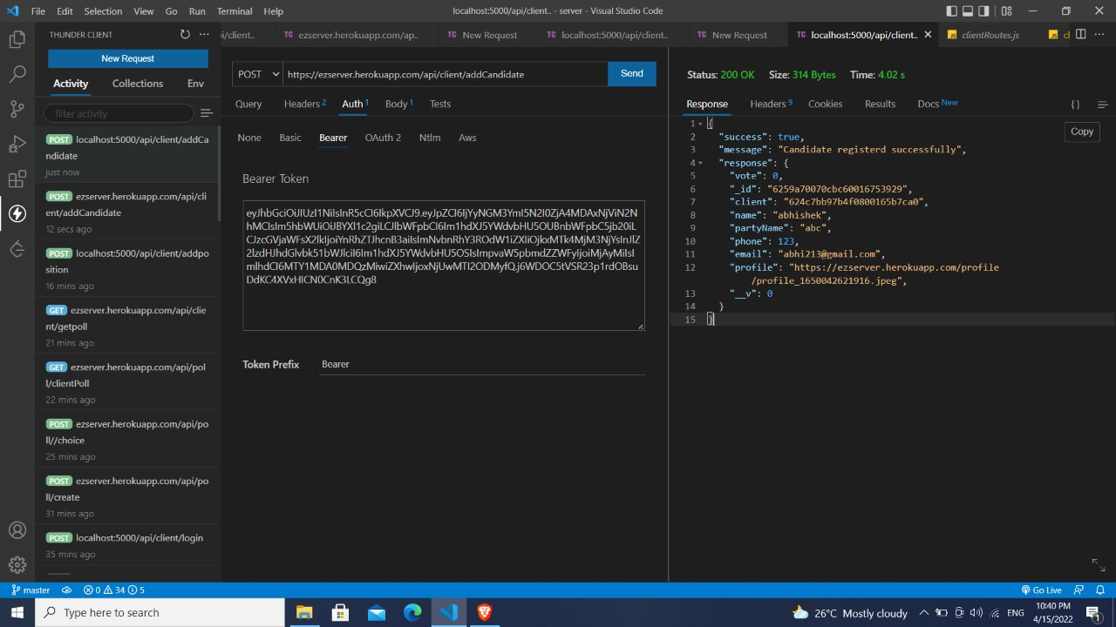

Taking the account through the complete process from poll creating to giving poll and from creating vote adding candidates, we ensured that none of the features were breaking and the app was performing in the same way as it meant to me.

We also ran the tests in various devices and resolutions to make sure the UI did not vary incorrectly. This process was repeated with varying the inputs and corner case inputs to check for integrity of the application. We employed various techniques to test input validation, including bug checks.

## System Testing

We performed manual System testing on a complete integrated system to evaluate the compliance of the system with all the requirements.

We tested the design and behavior of the system and also the expectations of the customer.

1) **CLIENT REGISTRATION**

|  |  |
| --- | --- |
| **TEST CASES** | **RESULT** |
| User registration with new email id | Successful user registration |
| User registration with already registered email id | User already existing error |
| User registration with wrong email id | Enter valid email id |

**2) LOGIN**

|  |  |
| --- | --- |
| **TEST CASES** | **RESULT** |
| Login with correct email and password | Logged in Successfully |
| Login with wrong email and password | Wrong credentials error |
| Login with correct email and wrong password | Wrong credentials error |

**3) CREATE POLL**

|  |  |
| --- | --- |
| **TEST CASES** | **RESULT** |
| Create Poll without login | Redirects to login page |
| Create poll with correct login credentials | Poll successfully created. |

**4)** **CREATE VOTE**

|  |  |
| --- | --- |
| **TEST CASES** | **RESULT** |
| Create Vote | The vote is created with unique position Id |
| Add candidate with unique | The candidates are added successfully |
| Add candidate with same credentials | Shows error in creating candidate. |
| Add voter list | All voters are added and got emails with their login credentials. |

**5) GIVING VOTE TO POLL**

|  |  |
| --- | --- |
| **TEST CASES** | **RESULT** |
| Giving vote with unique IP | Vote taken and redirected to result page |
| Giving vote with same IP | Already Voted add |

**6) GIVING VOTE TO VOTE PORTAL**

|  |  |
| --- | --- |
| **TEST CASES** | **RESULT** |
| Login to voter with correct credentials | Redirected to vote page |
| Entering wrong credentials. | Throws error. |
| Selecting candidate and giving vote | OTP is send to registered email. |
| Entering correct OTP | Vote Successfully taken. |
| Same voter trys to give vote again | Redirected to home page. |